**inSight 2017**

**Department Problem Title Problem Code Problem Description**

**: Computer Science department**

**: Automated schedule tracker**

**: PS05**

**:**

The students meet the faculties every now and then and there is a high probability that they have to wait for the faculty since he/she is not free at that particular time. In order to avoid this application should be built in such a way that all the faculties or the people in the office (admin/main office) update their schedule. The calendar will be designed in such a way that it will reflect the timings when faculties are available and hence avoid the waiting time. Depending on the faculties free slot, the students may request a meeting. The meeting should be scheduled only if the faculty confirms .This application will be useful any official (including the principal) in the department. This should keep both student and faculties informed about all the schedules that they need.

**Proposed solution:**

*We will be developing an android application that would allow student and teacher interaction.*

*Separate logins are given to students and faculties[including admin/main office officials] .*

*Faculties should update their free schedule every day which will be stored on to the database.*

*Students can login and check for the availability of free slot of a particular faculty.*

*Student can select the slot that are available for meeting and requests a meeting with the faculty. Faculty must check if any meeting is requested by students and can either accept or deny the meeting.*

*Student can check if the faculty has accepted or denied the meeting.*

*If the meeting is fixed the slot will not be available for any other student.*

**Technology Stack :**

*We will be using :*

*Android studio.*

**Use Case:**

*On entering to the application two login options are provided one for the faculty another for student.*

*A database will be maintained ,where the faculty and their free slots will be frequently updated.*

*On logging in as a faculty they can update the database through their portal.*

*On logging in as a student they can view the faculty schedule for the day and can request a meeting for the free slot specified by the faculty.*

*When the student requests a meeting the database is accessed and information if retrieved. Faculty can check their portal for any meetings being requested , where on approval the particular slot will be deleted from the database.*

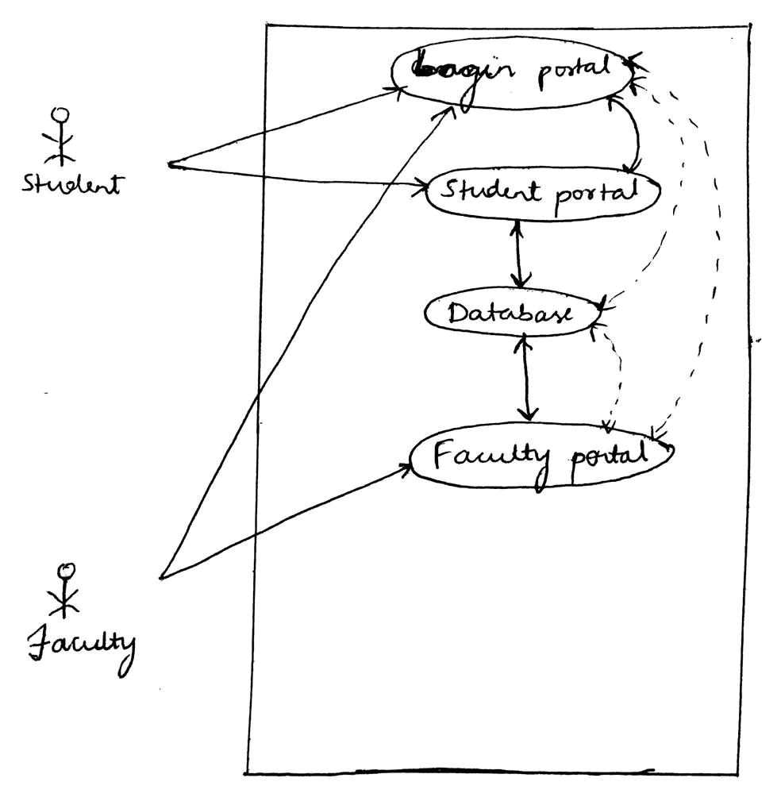

**Team Members details:**

|  |  |  |  |  |
| --- | --- | --- | --- | --- |
| **Role** | **Name** | **USN** | **Email id** | **Phone no.** |
| Team Leader | Rakshitha R | 1SI15CS086 | rakshita.ravi97@gmail.com | 8904547901 |
| Team Member 1 | Purushotham G K | 1SI15CS082 | p[urushotham.gkpl@gmail.com](mailto:Purushotham.gkpl@gmail.com) | 9590984828 |
| Team Member 2 | Bhuvan S | 1SI15CS139 | bhuvan.reddy98@gmail.com | 7795501929 |